Food Insecurity and Adverse Childhood Experiences (ACEs): The Role of the Pediatric Dietitian
Funded by MCHB Grant T73MC00008
Keywords: Adverse Childhood Events (ACEs), Childhood Food Insecurity, Public Programs

Learning Objectives
Participants will be able to:
- Identify childhood food insecurity as a related life event that contributes to the burden of ACEs.
- Discuss at least 3 key programs engaged in supporting children at risk of food insecurity
- Identify one strategy they can use to address childhood food insecurity and reduce its impact on ACEs

Introduction
The Center for Disease Control and Prevention (CDC) defines Adverse Childhood Events (ACEs) “as potentially traumatic events that occur in childhood.”¹ In a 2016 study which looked at 50,000 children aged 0-17 years, families reporting 3 or more ACEs were much more likely to experience food insecurity. In food secure homes, 1 out of every 25 children experienced 3 or more ACEs compared to 1 out of every 3 children in food insecure homes.² (See table 1 for definitions on food insecurity.) In 2018 Koita et al developed the Pediatric ACE and other Determinants of Health Questionnaire; a 17-item instrument that included the original 10 ACES and identified 7 additional items that are considered risk factors for toxic stress. The additional items, later described as related life events, included childhood food insecurity (Thakur et atl 2020).
Children understand food insecurity. In a study by Fram et al., 26 children from South Carolina aged 9-16 years generally described their experience of food insecurity better than their parents and identified strategies to manage when food was scarce.³ While this study was done in a small sample size in one geographic area, it provided a perspective on a child’s understanding of their experience of food insecurity. This added stress combined with hunger can impact performance in school and result in behavioral challenges, developmental delay and health issues like asthma and anemia.⁴ Those experiencing food insecurity often rely on energy-dense food sources, leading to an increase in the risk for obesity in addition to the risk for micronutrient deficiencies.⁵
Food insecurity is directly related to health equity in the U.S. according to Dr. Lavonna Lewis, Director of Diversity and Inclusion Initiatives at the USC Sol Price School of Public Policy. Dr. Lewis has advocated for food policy as an integral part of health equity for more than a decade, with an increased focus during the COVID-19 pandemic. “I just think that anyone who thinks that diversity, equity, and inclusion isn’t at the center of this conversation hasn’t been paying attention. Minoritized communities have been disproportionately affected by COVID-19, job loss, school disruptions and the limitations of accessing food through the school breakfast and lunch programs,” Lewis said. (interview, December 10, 2020). Her observation is supported by data from the USDA from 2019 in which 8% of White, non-Hispanic households, 19.1% of Black, non-Hispanic households, and 15.6% of Hispanic households were food insecure.⁶ Five million 300 thousand children (6.5% of the population) live in households that are food-insecure.⁶ An additional 7.1% of children who are not themselves food insecure live in food insecure households. Over 13% of children in the U.S. have some level of food insecurity in their household.⁶ Children who are not food insecure but live in a household with some food insecurity may be exposed to second-hand stress due to parental depression and anxiety, possibly resulting in poor caregiving practices.⁷
In response to the COVID-19 pandemic, overall food insecurity nearly tripled in March and April 2020 to 38%.⁸ During COVID-19, child-care and schools were shut down, incomes were dramatically reduced, poverty rates increased, and people lined up at foodbanks.^{8,5,9} In Los Angeles county, the prevalence of childhood food insecurity went from 1 in 7 children to 1 in 4 children in March 2020.¹⁰ This problem is more visible and urgent than ever before. Food banks have been mobilized to increase their services by 50% during the pandemic, however these efforts did not specifically focus on providing services for children.⁸ Low-income families with children face unique barriers to accessing food during the pandemic. Prior to the pandemic, some would visit multiple stores to make strategic financial purchases, travel long-distances if they were in food deserts, or utilize public transportation, all of which involve extra risk of exposure to the virus.⁵ Strategies families would use to feed themselves prior to the pandemic were complex, and only got more complicated as businesses and public transportation options began to diminish.

Nourishing the Whole Child
The adversity created by the pandemic and growing food insecurity, have forced programs that address childhood food insecurity to consider the whole child and their environment. The CDC’s Whole School, Whole Community, Whole Child (WSCC) model, developed in 2014, helps support youth in feeling healthy, safe, engaged, supported, and challenged in their schools (Figure 1).¹¹ This model includes four areas where pediatric dietitians can make an impact: health education, physical education and physical activity, nutrition environment and services, and health services. While children are not all physically in schools, it is important to be aware of programs that continue to support the whole child outside of their schools, in their communities and homes.

Food Security Programs
“Food insecurity is more ubiquitous right now, for better or worse, it’s the situation,” states Christine Tran, Executive Director of the Los Angeles Food Policy Council (interview, November 19, 2020). Nearly 30 million students participated in the School Breakfast Program (SBP) and National School Lunch Program (NSLP) daily, prior to the start of the pandemic.¹² For some of these students, school meals made up one-third to one-half of their calories in one day.¹² Given the number of students who rely on these programs for nourishment, it is important that families and children have access to food resources to fill in the gaps that are missing while participating in virtual learning. Steps have been taken to aid efforts in preventing children from feeling the burdens of food insecurity during this time. The Families First Coronavirus Response Act, passed in March 2020, helped strengthen previously existing programs like The Supplemental Nutrition Assistance Program (SNAP), the Child and Adult Care Food Program, and created programs to help replace school meals, like P-EBT.⁸ Other programs, like the Special Supplemental Nutrition Program for Women Infant and Children (WIC), have adapted to fit the changing needs of their population, moving to virtual programs and removing requirements to attend appointments in person. “It’s less about expansion and more about pivoting to meet the needs of children and their families”, says Tran (interview, November 19, 2020).
One program that has adapted significantly during the COVID-19 pandemic is the Child and Adult Care Food Program. In 2019, this program reimbursed 150,000 centers for meals and snacks fed to about 4.6 million children nationwide.⁹ The target population of this program is children aged 0-3 years old, including mainly childcare centers. However, many of these home and center daycares closed due to the pandemic, limiting distribution and access to food. As part of the Families First Coronavirus Response Act, USDA provided waivers for grab and go meals through the 2020-2021 school year for children who had reduced attendance or had stopped attending.⁹ This limited the ability to feed young children during this time, potentially exacerbating the food insecurity crisis we see today.
Another notable program developed during COVID-19 is Pandemic-Electronic Benefits Transfer (P-EBT), which was created in March 2020 as a response to the massive school shutdowns and the start of online learning for the majority of students in this country. P-EBT was passed as part of the Families First Coronavirus Response Act in March 2020.⁹ It provided food benefits to help families with children who are eligible for free or reduced-price school meals through the federal School Breakfast or National School Lunch Programs. The program provides approximately $114 per child per month in EBT benefits and can be used in addition to the families SNAP benefits.⁸ Parents can redeem their benefits at their local grocery store instead of waiting in lines to pick up school meals every day. The program initially suffered from low enrollment due to a lack of information to families on how to sign up and a limited enrollment period.^{14,15} A second version of P-EBT is being developed, pending federal approval, to include those who missed the enrollment period or who are newly eligible.¹⁶ Currently, some states are moving to a system where families do not have to apply, and all eligible families are enrolled. It’s important to encourage families to update their mailing addresses are updated at their child’s school to ensure they receive their P-EBT cards, if they are eligible.¹⁵
Several programs increased aid to fill in the gap created by the shift from in-person to the virtual learning environment. School districts received waivers from the USDA to expand the SBP and the NSLP to provide grab-and-go meals, home delivered meals, and expand hours of operation to fit the needs of their communities.¹² However, despite the quick actions of the USDA to provide these waivers, the impact of the program greatly depended on the individual school districts and their strategies.¹² While these programs helped fill in the gaps, they also encountered significant barriers including parent’s work schedules, access to a car or public transportation, geographic access to distribution sites, and language barriers.^{12,17} McLoughlin et al. conducted a mixed-methods study to evaluate emergency meal distribution and strategy implementation in four large urban school districts throughout the U.S., specifically in Los Angeles, New York City, Houston, and Chicago. They found that two distinct strategies for distribution were deemed effective: increasing the length of time and days that meals are offered and increasing the number of sites where meals are offered.¹² From this study, one could hypothesize that offering flexible hours and more distribution sites may help alleviate some of the burdens to accessing the food offered through this program. Two other programs that helped decrease the burden of food insecurity in school-aged children participating in online learning were the Summer Food Service Program (SFSP) and Seamless Summer Option (SSO).¹⁸ These programs were both extended through June 2021.¹⁷ These programs differ from the SBP and the NSLP because many of their sites target areas where at least 50 percent of children are eligible for free or reduced price school meals. At these sites, meals are provided to all children regardless of their income eligibility.¹⁸
Programs like WIC and SNAP have adapted significantly during the COVID-19 pandemic. WIC continues to provide quality nutrition assistance to lower-income women, infants, and young children throughout the pandemic, with more flexibility in their services.¹⁹ Participants access services and education online and there is more flexibility in food package requirements.¹⁹ Despite improving access for some, the change to a virtual format was not a panacea. A qualitative study conducted by McElrone et al. looked at some of the barriers to participation in WIC during the pandemic in Tennessee. Though this study had a small sample size (n = 24), the participants reported an inability to use benefits online, low stock of WIC-approved items, and adverse impact on their mental and emotional health.²⁰ Furthermore, participants in this study were not entirely aware of the flexibilities in the food package requirements, which was one of the most common barriers mentioned.²⁰
SNAP does not specifically provide services to children, however this program can still be a good resource for families who qualify. From March to August 2020, SNAP expanded its caseload increased by 6.2 million and suspended the three-month time limit on low-income adults to receive SNAP benefits.⁸ Nearly 1 in 4 children in the U.S. live in households that participate in SNAP.²¹

The dietitian’s role in advocating for pediatric food security
As pediatric nutrition professionals, there is a role to play as educators and advocates for patients. When working with children who are experiencing food insecurity and their families, it is important to use a trauma-informed lens to create an environment of support and compassion. The first step is to realize the impact of childhood food insecurity on a child’s wellbeing. The next step is to recognize signs and risk factors for childhood food insecurity. Sudden changes in circumstances like job loss or prolonged illness can put families and children at risk for food insecurity. The third step is to use knowledge about food insecurity to inform policies and practices. The final and often the most important step is to resist causing unintended harm.²² Programs that sought to provide support to children experiencing food insecurity by sending home food in backpacks, discovered that families felt stigmatized.²³
As a pediatric dietitian, the goal is to improve the health of the whole child and this includes reducing the impact of food insecurity.²⁴ Pediatric nutrition professionals can advocate for their patients by supporting policies that are rooted in the safety of children and prevention of childhood food insecurity.²⁴ Pediatric nutrition professionals have a role in preventing future ACEs. The Academy of Nutrition and Dietetics has laid out specific impact goals related to the topic of food insecurity as part of their strategic plan created in 2021. The goals include “increasing equitable access to and utilization of safe nutritious food and water and championing legislation and regulations that increase food and nutrition security throughout the lifecycle”.²⁵

Call to action
There are many ways to get involved in reducing ACEs and food insecurity in your community. First, become an active part of the community. This can help shed light on the needs of the community and help develop programs that meet those needs (see resources section for ideas on how to find food resources in your community).
When possible, partner and collaborate with other groups that address hunger, food sustainability, and school food service. These can include the local food bank, the nearest WIC branch, or a farmer’s market nearby. It is important to not only know the resources, but also to be able to provide that knowledge to patients who need it the most. Including questions on food insecurity as part of general nutrition screening can help identify patients that need these resources. The American Academy of Pediatrics advocates for the use of a validated two question screening tool to measure food insecurity, known as the Hunger Vital Sign (HVS). Instead of the categorical response options used in the validated HVS of “often true”, “sometimes true”, and “never true”, the AAP recommends the answer choices of Yes or No.²⁷
“Within the past 12 months, we worried whether our food would run out before we got money to buy more. Yes or no?
Within the past 12 months, the food we bought just didn’t last and we didn’t have money to get more. Yes or no?”
Children who experience food insecurity need advocates. One way to be an advocate to prevent childhood food insecurity is to call representatives in Congress, local and state leaders, and other advocates with specific, targeted requests to increase funding for programs like CACFP, P-EBT, SNAP, WIC, and the Summer Food Program. Encourage representatives to draft policies targeted towards children that increase autonomy and reduce trauma and stigma in accessing food. Go to the Food Research Action Center website to check the status of the P-EBT rollout in a specific state.
Childhood food insecurity is preventable. Pediatric dietitians can play an active part in identifying food insecurity as a related life event that contributes to the burden of ACEs and engaging in practices to reduce its impact. See table 2 for ways to get involved with the Academy’s focus on food and nutrition safety and security.

Available resources:
- Websites
  - Information on ACEs:
    - Joining Forces for Children https://www.joiningforcesforchildren.org/what-are-aces/;
    - ACEs Aware https://www.acesaware.org/?gclid=CjwKCAjwiaX8BRBZEiwAQQxGx9mLgKcjn6gN3EKK9xJxrY5tMxb6qU45-_ksd-_nySDNKOfqVedPpBoCCp0QAvD_BwE;
    - ACEs Prevention https://www.childwelfare.gov/topics/preventing/preventionmonth/resources/ace/
  - Food resources
    - Essential needs services from 211 hotline https://www.211.org/services/essential-needs
    - Food Finder https://foodfinder.us/
    - Local food bank finder https://www.feedingamerica.org/find-your-local-foodbank
    - Immigrant eligibility for food assistance information https://protectingimmigrantfamilies.org/immigrant-eligibility-for-public-programs-during-covid-19/
    - Food Research Action Center- https://frac.org/research/resource-library/state-p-ebt-programs-map

References
1. CDC. Adverse Childhood Experiences (ACEs). Published December 3, 2019. Accessed April 15, 2021. https://www.cdc.gov/vitalsigns/aces/index.html
2. Jackson DB, Chilton M, Johnson KR, Vaughn MG. Adverse Childhood Experiences and Household Food Insecurity: Findings From the 2016 National Survey of Children’s Health. Am J Prev Med. 2019;57(5):667-674.
3. Fram MS, Frongillo EA, Jones SJ, et al. Children are aware of food insecurity and take responsibility for managing food resources. J Nutr. 2011;141(6):1114-1119.
4. Facts About Child Hunger in America. Accessed February 3, 2021. https://www.feedingamerica.org/hunger-in-america/child-hunger-facts
5. Kinsey EW, Kinsey D, Rundle AG. COVID-19 and food insecurity: An uneven patchwork of responses. J Urban Health. 2020;97(3):332-335.
6. Key Statistics & Graphics. Accessed February 3, 2021. https://www.ers.usda.gov/topics/food-nutrition-assistance/food-security-in-the-us/key-statistics-graphics.aspx
7. Zaslow M, Bronte-Tinkew J, Capps R, Horowitz A, Moore KA, Weinstein D. Food security during infancy: implications for attachment and mental proficiency in toddlerhood. Matern Child Health J. 2009;13(1):66-80.
8. Wolfson JA, Leung CW. Food Insecurity During COVID-19: An Acute Crisis With Long-Term Health Implications. Am J Public Health. 2020;110(12):1763-1765.
9. Bauer KW, Chriqui JF, Andreyeva T, et al. A Safety Net Unraveling: Feeding Young Children During COVID-19. Am J Public Health. 2021;111(1):116-120.
10. Food Insecurity April to July – USC Public Exchange. Accessed February 3, 2021. https://publicexchange.usc.edu/food-insecurity-april-to-june/
11. The Whole School, Whole Community, Whole Child (WSCC) Model. Published February 6, 2020. Accessed February 3, 2021. https://www.cdc.gov/healthyyouth/wscc/model.htm
12. McLoughlin GM, McCarthy JA, McGuirt JT, Singleton CR, Dunn CG, Gadhoke P. Addressing Food Insecurity through a Health Equity Lens: a Case Study of Large Urban School Districts during the COVID-19 Pandemic. J Urban Health. 2020;97(6):759-775.
13. Your Baby’s First 1,000 Days: AAP Policy Explained. Accessed February 3, 2021. https://www.healthychildren.org/English/ages-stages/baby/Pages/Babys-First-1000-Days-AAP-Policy-Explained.aspx
14. Sinha IP, Lee AR, Bennett D, et al. Child poverty, food insecurity, and respiratory health during the COVID-19 pandemic. Lancet Respir Med. 2020;8(8):762-763.
15. Lessons from early implementation of pandemic-EBT. Accessed April 9, 2021. https://www.cbpp.org/research/food-assistance/lessons-from-early-implementation-of-pandemic-ebt
16. Food Stamps/SNAP Applications. Accessed February 3, 2021. https://www.211la.org/resources/service/food-stampssnap-applications-64
17. Nationwide Waiver to Allow SFSP and Seamless Summer Option Operations through SY 2020-2021 – Extension. Accessed February 3, 2021. https://www.fns.usda.gov/cn/covid-19-response-59
18. Q & A: Summer Food Service Program. Accessed April 16, 2021. https://www.acf.hhs.gov/ofa/faq/q-summer-food-service-program
19. USDA Extends WIC COVID-19 Flexibilities for Duration of the COVID-19 Public Health Emergency. Accessed February 3, 2021. https://www.usda.gov/media/press-releases/2020/09/21/usda-extends-wic-covid-19-flexibilities-duration-covid-19-public
20. McElrone M, Zimmer MC, Anderson Steeves ET. A qualitative exploration of predominantly white non-Hispanic Tennessee WIC participants’ food retail and WIC clinic experiences during COVID-19. J Acad Nutr Diet. Published online February 3, 2021. doi:10.1016/j.jand.2020.12.011
21. SNAP Helps Millions of Children. Accessed February 5, 2021. https://www.cbpp.org/research/food-assistance/snap-helps-millions-of-children
22. Oral R, Ramirez M, Coohey C, et al. Adverse childhood experiences and trauma informed care: the future of health care. Pediatr Res. 2016;79(1-2):227-233.
23. Fram MS, Frongillo EA. Moving Beyond Giving Free Food: Specific Targeting and Tailoring in Response to Child Food Insecurity. J Acad Nutr Diet. 2021;121(1S):S74-S77.
24. Jackson & Chilton. Adverse Childhood Experiences and Household Food Insecurity: A crisis among America’s children and families. Accessed February 3, 2021. https://drexel.edu/~/media/Files/hunger-free-center/research-briefs/acesfoodinsecurity2019.ashx
25. Academy of Nutrition and Dietetics Strategic Plan. The Academy of Nutrition and Dietetics. Accessed February 5, 2021. https://www.eatrightpro.org/-/media/eatrightpro-files/leadership/bod/strategic-plan/academy-of-nutrition-and-dietetics_strategic-plan_sep-2017.pdf?la=en&hash=D00E3FE00D1475FB416E20004DECC3C136D5D7E5
26. Self Care Tool For Pediatrics. Accessed February 3, 2021. https://www.acesaware.org/wp-content/uploads/2019/12/Self-Care-Tool-for-Pediatrics.pdf
27. O’Keefe L. Identifying food insecurity: two-question screening tool has 97% sensitivity. AAP News. 2015;36(10):E151023-151021.

Figure 1.
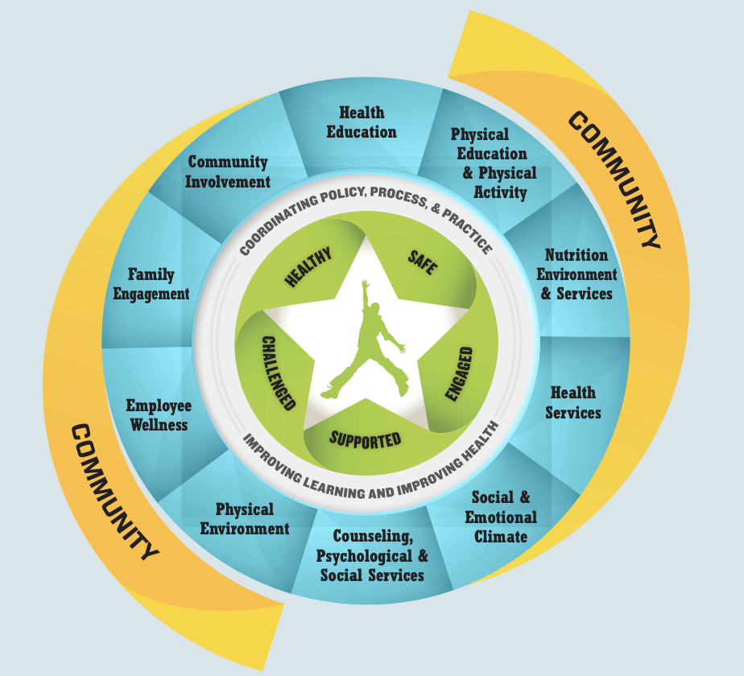
Footnote: The Whole School, Whole Community, Whole Child (WSCC) model was developed to help communities, healthcare professionals, and schools combine resources to support the whole child during their growth. The pediatric dietitian can integrate nutrition across the WSCC framework, especially in the areas of health education, physical education and physical activity, nutrition environment and services, and health services.¹¹

Table 1.
Table 1. Definitions of Food Insecurity
Individual Food Insecurity: Having inadequate access to sufficient, safe, and nutritious food to meet needs for an active and healthy lifestyle.

Household Food insecurity: Inadequate access to sufficient food for all household members to lead an active, healthy life.

Childhood Food Insecurity: The quality or quantity of food for children is diminished due to a family’s lack of resources.

Table 2.
Table 2. Ways to Get Involved
Read the Academy’s position paper on food insecurity in the United States https://www.eatrightpro.org/-/media/eatrightpro-files/practice/position-and-practice-papers/position-papers/position_-food-insecurity_final.pdf?la=en&hash=EBB2CE062DFEFCA452073E3744994066E154D8A6

Sign up for Action Alerts to advocate policy issues important to Academy members
https://www.eatrightpro.org/advocacy/take-action/action-center

Get involved in grassroots advocacy efforts through the Academy’s Local Advocacy page
https://www.eatrightpro.org/advocacy/take-action/local-advocacy

Stay updated on PNPG policy information
https://www.pnpg.org/public-policy-for-pediatric-nutrition-legislation

